Facilitator Notes
Handout starts on page 2.

Does anyone remember RCAs? (5 mins)
- Do a show of hands
- This will help gauge how many are new to this and thus you may need to slow down and explain more on the RCA process first before anything else.

Okay, so who can tell me what an RCA is? (5 mins)
- Discuss
- Read equivalent section on page 1 of handout.
- Go through the TRADITIONAL RCA MODEL

And how does it differ from a CBD? (5 mins)
- Discuss
- Read equivalent section on page 1 of handout.

Okay, so who can tell me what the purpose of an RCA is? (5 mins)
- Discuss
- Read equivalent section on page 1 of handout. (JOHARI BIT)

Let’s see how we can do this during Debriefs (10 mins)
Follow process outlined on page 2 of the handout

Let’s have a go… just a bit of fun… to see if it works. (40 mins)
Ask the audience to refer to the process on page 2 of the handouts if they are stuck – which details this…
- Pick a case at random from trainee’s surgery list (or each case one by one if ST1 or 2)
- Ask trainee to present it in 30 secs & any difficulties, read the notes they made.
- Explore what the trainee did
- Explore why they did that
- Change the scenario a little
- Ask them what they would do then and why
- Change it a bit more, repeat questioning
- Teach along the way
- After 4-5 mins, pick another case
Facilitator to demonstrate first
- Demonstrate a single consultation debriefed RCA style.
- Pick John Heaney (see attached rca-sample surgery attachment).
- Ask for someone to play the trainee – and use the same person to play the trainee in the next bit.
Pick another to play the RCA case…as the trainer.
Indicate this is just for fun. In fact, the scripts have been written. They are not designed to test your knowledge but rather make you play the trainer and trainee as described. So, be reassured that no-one will be clinically judging you. However, this is a great place to have a go at Debriefing RCA style. Facilitator will give you the rca-sample surgery with instructions. Others can have a turn if they want (there are 4 cases in total).

HANDOUT - What is an RCA?
Random Case Analysis – pick a case at random. And analyse it! Simple. You can examine what the trainee did and why they did that. You can alter the scenario a little and test them on that too.

What does the TRADITIONAL RCA process look like?
- Pick a case at random from trainee’s surgery list
- Ask trainee to present it in 2-3 mins & any difficulties, read the notes they made.
- Explore what the trainee did
- Explore why they did that
- Change the scenario a little
- Ask them what they would do then and why
- Change it a bit more, repeat questioning
- Perhaps a bit more? (you decide when to stop)
- Teach along the way & get them to write down learning points.
- After 20 mins, pick another case

How does it differ from a CBD?
- In a CBD, you have to stick to the ‘here and now’. In other words, you can only ask what they actually did and why. You cannot change the scenario and thus you cannot ask “What if….” questions.
- Also, in a CBD , there are set areas to explore as defined by the CBD marking crib. With RCAs you can go anywhere you like – and that means a RCA allows you more freedom to use your experience and expertise.

What’s the purpose of an RCA? What are we actually doing?
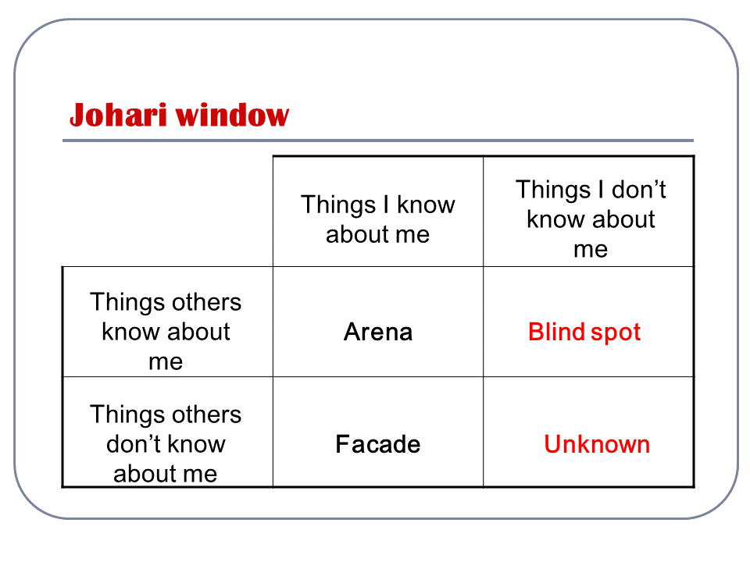
Basically RCAs work on the Johari’s Window UNKNOWN box. Do you remember that? Here it is.

Doctors are often used to a culture where the admission of learning needs leads to blame or ridicule, so the `facade' is maintained. We are often poor at giving feedback to each other, so opportunities for reducing our `blind spots' can be very limited. The discussion of randomly chosen cases in a safe and constructive setting can help to enlarge the `arena', thus enabling the trainee to increase their self-knowledge, and to be able to share and deal with difficulties normally kept out of sight in the `facade'.

- RCAs encourage trainees to reflect on the case by examining their own knowledge, skills and attitudes.
- RCAs are very good at QUICKLY identifying poor knowledge learning needs (helps with AKT/CSA).
- RCAs help create cognitive dissonance in trainees in their knowledge, skills and attitudes. And this then motivates change by their subsequent desire to bridge the gap. In other words, RCAs help trainee face the problem they may be avoiding e.g. poor knowledge.

How to Debrief with RCAs (what I call “RCA Debriefs”)
Basically, the method is the same as with the traditional model of doing RCAs – except you do it lots quicker because time is precious! So, it will go something like this… (difference highlight in red)
- Pick a case at random from trainee’s surgery list (or each case one by one if ST1 or 2)
- Ask trainee to present it in 30 secs & any difficulties, read the notes they made.
- Explore what the trainee did
- Explore why they did that
- Change the scenario a little
- Ask them what they would do then and why
- Change it a bit more, repeat questioning
- Teach along the way & get them to write down learning points.
- After 4-5 mins, pick another case

Some key points in doing RCA Debriefs
- Don’t let the trainee talk too much at the start when they are describing the case.
- Listen and then respond - using the same skills that you would in a consultation - active listening, picking up and responding to cues, clarifying.
- Explore knowledge, skills and/or attitudes – the trainee may be well aware of own strengths and weaknesses – the challenge here is to help them open up new insights .
- The trainer has to be on his toes to spot problem areas of which the trainee may be unaware.
- For skills – do some quick practice eg phrases they would use
- For attitudes - asking about feelings is one way of moving domains if they are stuck in biophysical model
- Don’t forget to teach – little nuggets, signpost to deeper stuff – help them construct their own knowledge
- Much of this has parallels with the skills you already use in the consultation!

